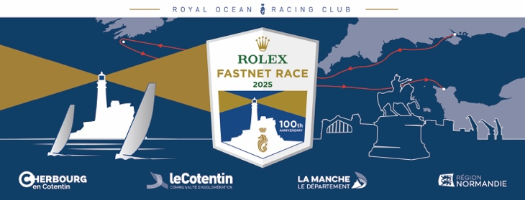

**Schedule of Events & Media Highlights 2025**

**DATE TIME EVENT**

**Weds 16 July 1000 (BST) COWES - Media Centre opens, Cowes Yacht Haven, Event Centre**

**Fri 18 July 1400 (BST) COWES - Admiral’s Cup Press Conference – RORC Cowes  
Fri 18 July 1600 (BST) COWES – Admiral’s Cup Skippers Briefing – RORC Cowes**  
Thurs 24 July 1100 (CEST) CHERBOURG - Media Centre opens, Cherbourg-en-Cotentin, Race Village

Thurs 24 July 1600 (CEST) **CHERBOURG - Press Conference with elected officials + skippers - La Plage Vert**

Thurs 24 July 1800 (CEST) **CHERBOURG – Crew Presentation & Show, Race Village - La Plage Vert**

**Thurs 24 July 2000 (CEST) COWES Crew Party – RORC Cowes**

**Fri 25 July 1400 (BST) COWES - Rolex Fastnet Race Press Conference – RORC Cowes   
+ online & on the giant screen in the Cherbourg Race Village**

**Fri 25 July 1600 (BST) COWES - Rolex Fastnet Race Skippers & Weather Briefing – RORC Cowes/online**

Sat 26 July 1000 (CEST) CHERBOURG – Race Village Officially Opens

**Sat 26 July 1100 (BST)** **COWES – 100th Anniversary Rolex Fastnet Race - START - Live broadcast begins**  
With commentary on and off the water, and live coverage of the whole start sequence - on RORC Facebook + YouTube + Race Website

**Sat 26 July 1110 (BST) COWES – First Warning Signal – Start of the 2025 Rolex Fastnet Race, RYS**Mon 28 July 1800 (CEST) CHERBOURG - ULTIM prizegiving ceremony & concert - La Plage Vert

Tues 29 July 1800 (CEST) CHERBOURG - IMOCA + Ocean Fifty prizegiving ceremony & concert - La Plage Vert

Weds 30 July 1800 (CEST) CHERBOURG - Class40 prizegiving ceremony & concert – La Plage Vert

Thurs 31 July 1600 (CEST) CHERBOURG - Patrouille de France Air Show – Collignon Beach/flyover Race Village

Thurs 31 July 1800 (CEST) CHERBOURG - Admiral’s Cup Prizegiving

**Fri 1 Aug 1800 (CEST) CHERBOURG –100th anniversary Rolex Fastnet Race Main Prizegiving - Race Village, La Plage Verte - followed by concert  
Race Village closes at 0100**